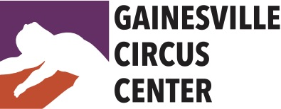

Performance Opportunities

Performances are a vital part of a performing arts education.
We encourage all students to participate in performance opportunities with Gainesville Circus Center (GCC). There are several recurring and spontaneous opportunities to perform each year. It is, however, an immense responsibility. Please read carefully the obligations and terms of agreement.
OBS: Auditions are required all participants in any given performance opportunity unless otherwise noted. Students auditioning for solos must present a minimum of 2 minutes (maximum 4 minutes) of prepared choreography with music. However, it is not required to audition as a soloist in order to participate in a show, however, ALL soloists are required to participate in group acts.
2021 Performance Schedule:

GCC Spring Student Showcase

Saturday, April 24, 6pm
Group Audition: Open to ALL students maintaining regular training schedules in technique class(es). Limit: 1 group act per performer.
Solo/Duo Audition: Friday, April 2, 5:30pm
Rehearsals: In-Class Technique/Choreography rehearsals Feb 15 – April 22 + ALL CAST rehearsals Wednesdays & Fridays April 14 - 23, 6pm-8pm
Location: Gainesville Circus Center

Public School Demo: Sidney Lanier Center

May 28, 1pm
Solo/Duo Audition: Video submission to info@gainesvillecircus.com. Deadline May 15
Rehearsal: Thursday, May 27, 7:00pm
Location: Sidney Lanier Center, 312 NW 16th Ave, Gainesville, FL 32601

Independance Festival

June 13, 2pm & 6pm
Solo/Duo Audition: Via video submission to info@gainesvillecircus.com. Deadline May 30
Rehearsals: Friday, June 11, 5:30pm
Location: Heartwood Soundstage, 619 S Main, Gainesville, 32601

GCC Summer Student Showcase

Saturday, August 14, 3pm & 6pm
Group Audition: July 19 – 22 (In Class) Open to ALL students maintaining regular training schedules in technique class(es). Limit: 1 group act per performer.
Solo/Duo Audition: Friday, July 23, 5:30pm
Rehearsals: In-Class Technique/Choreography rehearsals May 31 – Aug 13 + ALL CAST rehearsals Saturdays 2pm-4pm & Fridays 6pm-7pm / July 30 – Aug 7.
Tech/Dress Rehearsal: August 13, 5pm – 8:30pm
Location: Gainesville Circus Center

5. Gainesville Downtown Festival & Art Show

Nov 6 & 7, 10:30am, 12:30pm & 2:30pm
Auditions: Group Audition (all soloists must attend) - Friday, Sep 10, 6pm
Group Rehearsals Sept 10 – Nov 12, exact days/times TBD
Solo Audition – Saturday, Oct 2, 10am
Rehearsal Location: Gainesville Circus Center
Downtown Arts Performance: SE 2nd Place – near The Hipp

6. Two Hawk Christmas Circus
Dec 11, 12pm & 3pm
Auditions & Rehearsals: TBD
Rehearsal Location: Gainesville Circus Center
Christmas Circus Performance: Two Hawk Hammock, Williston, FL

Requirements:
Rehearsals
Rehearsals are mandatory to participate in performances unless otherwise noted. Advance notice of absence may be negotiated with GCC, understanding that any performance participation may be reduced to a minor role. Unexcused absences will result in removal from the performance without a refund. Rehearsal tardiness may also result in removal from performances.
Students participating in performances/rehearsals must maintain a minimum of 1/week regular class training. Rehearsals are charged as regular classes – students who train once per week and wish to rehearse for a performance opportunity will need to purchase at a class package that accommodates all necessary training & rehearsal requirements.
Rehearsal schedule is subject to change. Dress rehearsal typically takes place the day before a performance, however, GCC reserves the right to call an additional tech rehearsal within the week prior to the performance. Performers are expected to make every best effort to attend and participate in any additional rehearsals as needed.
Performance Roles
Performance roles will be assigned based on each student’s technique, maturity, availability, and stage experience. Remember: every job is an important one. No performer is guaranteed a solo!
Fees
Participation in rehearsal is required for performance. Rehearsals are charged as classes. Additionally, there is a one-time $125 annual performance fee for participation in any / all of the performance opportunities. Alternatively, students can opt to pay $75 per-performance fee for participation in a single performance. Performance fees are required of all students and staff to cover the costs of event production. Fall Shows: Downtown Arts Festival (Nov 7 & 8) & Country Circus (Nov 13) are each considered 1 performance.

Costumes
Costumes will be provided by Gainesville Circus Center. Costumes must be returned to the GCC wardrobe closet immediately following performance. All performers are expected to supply their own tights, undergarments appropriate to dancewear, and makeup.

Hair and Make-Up
It is the responsibility of each performer to arrive at their performance site with hair and make-up done, or, time permitting, do their hair & make-up onsite. Hair must be secured out of the face with gel/spray, rubber bands and/or pins unless otherwise instructed. Make-up is required for all genders. Make-up style should reflect traditional stage make-up (see below) unless otherwise indicated. Exotic and non-traditional make-up designs must be approved by GCC staff prior to performance. For assistance, please inquire prior to performance date.

Stage make-up examples:
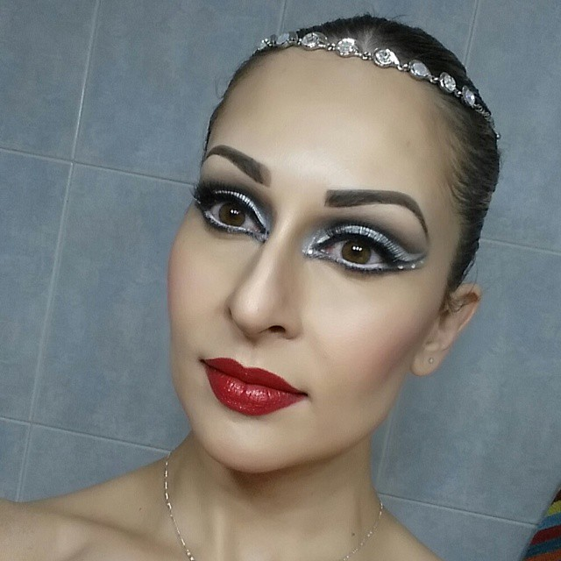

Arrival/Departure/Participation
“Better late than never” need not apply. Rehearsals will begin on time to the minute. There will be a 5-minute grace period for late arrivals. Any performer arriving late more than once may be subject to removal from the performance without a refund. Performances also will be held on time and performers must arrive a minimum of one hour prior to their performance time with hair and make-up done. Once the performance is complete, return all costumes to the wardrobe immediately. ALWAYS bring flip-flops or slip-ons to outdoor shows. NEVER eat in costume.
Set-Up & Break-Down
All adult performers are required to participate in set-up and/or break-down for each performance in which they participate. Set-up and break-down schedules will be determined within a week of each performance date.

Film & Photography
Gainesville Circus Center, Inc & Ascendance Entertainment, LLC often film and/or photograph performances for use as promotional material for future events. By participating in performances sponsored by Gainesville Circus Center, Inc and/or Ascendance Enterainment, LLC, student acknowledges full consent and release of film and/or photographs obtained during performances, which may include the student.
I have read the performance opportunities rules & requirements provided by Gainesville Circus Center.
I agree to the above terms and conditions and understand that my lack of cooperation and/or participation may result in my removal from any or all performance opportunities. Furthermore, I agree to pay the required performance fee on or before the first rehearsal date.

Student Signature Date

________________________________________________________
Parent or Guardian Signature Date
(If student is a minor)

